# Logical ERD & Relational Schema

## Logical ERD

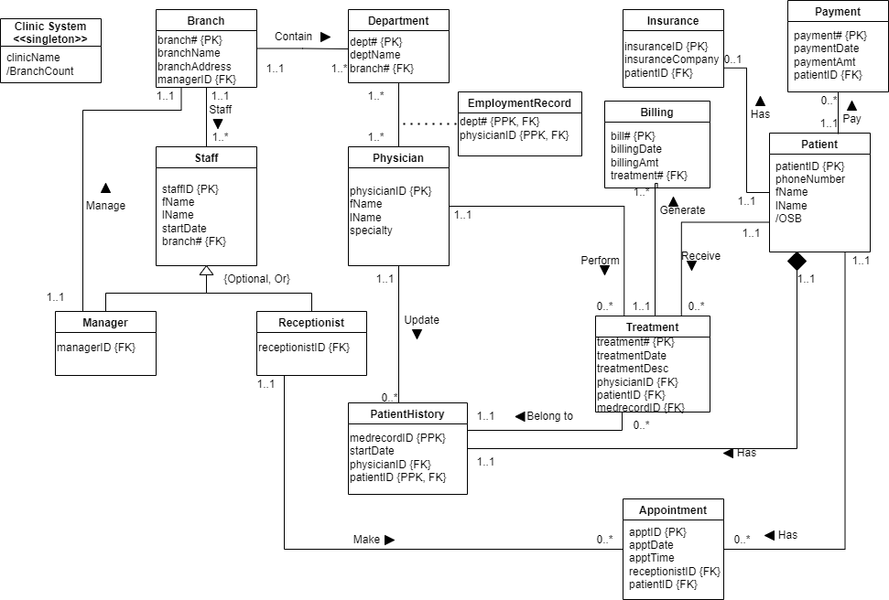

## Relational schema

Clinic System (clinicName)

Branch (**branch#**, branchName, branchAddress, managerID)

Foreign Key managerID REFERENCES Manager (staffID);

Staff (**staffID**, fName, lName, branch#)

Foreign Key branch# REFERENCES Branch (branch#);

Manager (**managerID**)

Foreign Key managerID REFERENCES Staff (staffID);

Receptionist (**receptionistID**)

Foreign Key receptionistID REFERENCES Staff (staffID);

Department (**dept#**, deptName, branch#)

Foreign Key branch# REFERENCES Branch (branch#);

EmploymentRecord (**dept#, physicianID**)

Foreign Key dept# REFERENCES Department (dept#);

Foreign Key physicianID REFERENCES Physician (physicianID);

Physician (**physicianID**, fName, lName, specialty)

Patient (**patientID**, phoneNumber, fName, lName)

Treatment (**treatment#**, medrecordID, treatmentdate, treatmentdesc, patientID, physicianID)

Foreign Key patientID REFERENCES Patient (patientID);

Foreign Key physicianID REFERENCES Physician (physicianID);

Foreign Key medrecordID REFERENCES PatientHistory (medrecordID);

Insurance (**insuranceID**, patientID, insurancCompany)

Foreign Key patientID REFERENCES Patient (patientID);

PatientHistory (**medrecordID**, **patientID**, startDate, description, physicianID)

Foreign Key patientID REFERENCES Patient (patientID);

Foreign Key physicianID REFERENCES Physician (physicianID);

Appointment (**apptID,**  receptionistID, patientID, apptTime)

Foreign Key receptionistID REFERENCES Receptionist(receptionistID);

Foreign Key patientID REFERENCES Patient (patientID);

Billing (**bill#,** billingDate, billingAmt, treatmentID)

Foreign Key patientID REFERENCES Treatment (treatmentID);

Payment (**payment#**, paymentDate, paymentAmt, patientID)

Foreign Key patientID REFERENCES Patient (patientID);